Lab 2: Exploring Additional AI Coding Tools beyond Copilot – Gemini (Colab) and Cursor AI
Task Tool you should use What you do
Task 1 – Statistical Summary Google Gemini + Google Colab Give the prompt to Gemini → get code → put/run the code in Colab → show output
Task 2 – Armstrong Number Gemini + GitHub Copilot Generate one version with Gemini and another with Copilot → run/test both → compare
Task 3 – Leap Year Cursor AI Give Prompt 1 in Cursor → run code → give Prompt 2 → run code → compare
Task 4 – Odd/Even Sum VS Code/any Python editor + AI tool First write your own code → then give it to an AI tool for refactoring → run both versions
Task 1: Statistical Summary for Survey Data
Scenario:
You are a data analyst intern working with survey responses stored as numerical lists.
Task:
Use Google Gemini in Colab to generate a Python function that reads a list of numbers and calculates the mean, minimum, and maximum values.
Expected Output:
Correct Python function
Output shown in Colab
Screenshot of Gemini prompt and result
PROMPT:(Gemini)
Write a Python function that accepts a list of numbers and calculates and returns the mean, minimum, and maximum values. Include an example using a list of survey responses and display the results clearly."
CODE:(COLAB)
def calculate_statistics(numbers):
"""
Calculates and returns the mean, minimum, and maximum of a list of numbers.
"""
if not numbers:
return None, None, None
total_sum = sum(numbers)
count = len(numbers)
mean_val = total_sum / count
min_val = min(numbers)
max_val = max(numbers)

return mean_val, min_val, max_val

# Example: Survey responses (e.g., customer satisfaction ratings from 1 to 10)
survey_responses = [8, 9, 6, 7, 10, 5, 8, 9, 7, 8, 10, 4, 9, 8, 7]

# Calculate statistics
mean_rating, min_rating, max_rating = calculate_statistics(survey_responses)

# Display the results clearly
print("Survey Results Summary")
print("----------------------")
print(f"Total Responses: {len(survey_responses)}")
print(f"Average Rating: {mean_rating:.2f}")
print(f"Minimum Rating: {min_rating}")
print(f"Maximum Rating: {max_rating}")
OUTPUT:
PROMPT: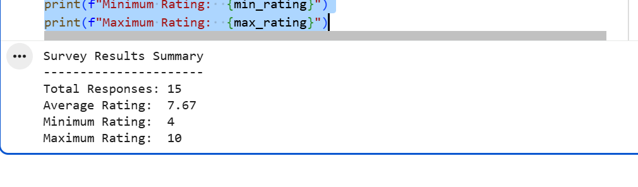 Task 2: Armstrong Number – AI Comparison
Scenario:
You are evaluating AI tools for numeric validation logic.
Task:
Generate an Armstrong number checker using Gemini and GitHub Copilot.
Compare their outputs, logic style, and clarity.\
Expected Output:
Side-by-side comparison table
Screenshots of prompts and generated code.
GEMINI PROMPT:
Write a Python program to check whether a given number is an Armstrong number. Explain the logic clearly and include a sample input and output."
CODE:
def is_armstrong_number(number):
# Convert the number to a string to easily count digits and iterate
num_str = str(number)
num_digits = len(num_str)

# Calculate the sum of digits raised to the power of num_digits
armstrong_sum = sum(int(digit) ** num_digits for digit in num_str)

# Check if the sum matches the original number
return armstrong_sum == number

# Test cases
test_numbers = [153, 370, 9474, 9475, 123]

for num in test_numbers:
if is_armstrong_number(num):
print(f"{num} is an Armstrong number.")
else:
print(f"{num} is NOT an Armstrong number.")
OUTPUT:
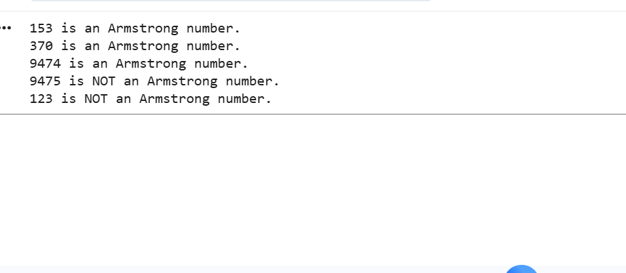
GitHub Copilot Prompt
# Write a Python function to check whether a number is an Armstrong number
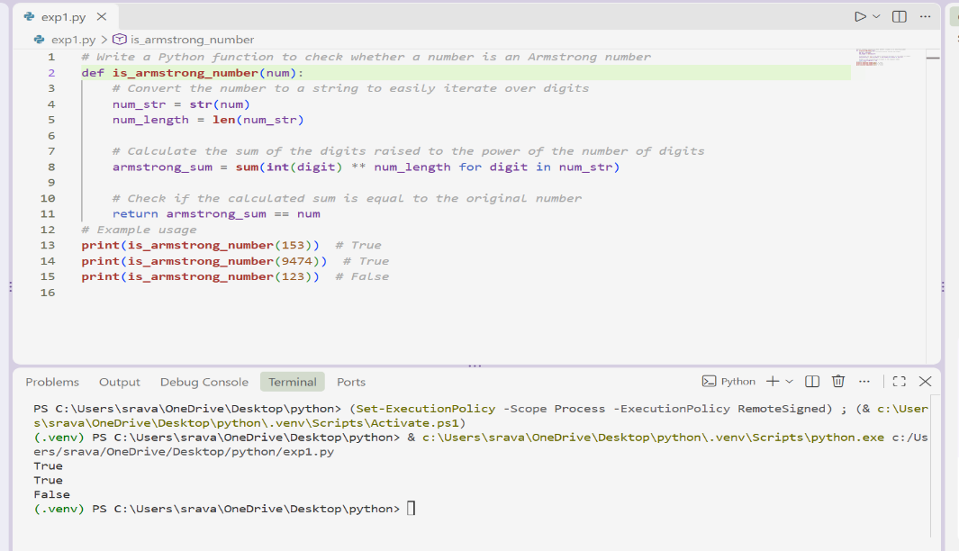
Observation
Both tools successfully generated working Armstrong-number logic. The Gemini version is concise because it converts the number into a string and processes each digit. The Copilot version uses mathematical operations such as % 10 and // 10 to extract digits.
Neither approach is inherently incorrect. The choice depends on whether the priority is simplicity and readability or demonstrating mathematical digit-processing logic.
Task 3: Leap Year Validation Using Cursor AI
Scenario:
You are validating a calendar module for a backend system.
Task:
Use Cursor AI to generate a Python program that checks whether a given year is a leap year.
Use at least two different prompts and observe changes in code.
Expected Output:
Two versions of code
Sample inputs/outputs
Brief comparison
PROMPT:
Prompt 1 – Basic Prompt
"Write a simple Python program that accepts a year and checks whether it is a leap year."
Version 1
year = int(input("Enter a year: "))

if year % 400 == 0:
print(year, "is a leap year.")
elif year % 100 == 0:
print(year, "is not a leap year.")
elif year % 4 == 0:
print(year, "is a leap year.")
else:
print(year, "is not a leap year.")
Sample Output 1
Enter a year: 2024
2024 is a leap year.
Sample Output 2
Enter a year: 1900
1900 is not a leap year.

Prompt 2 – Improved Prompt
"Create a clean and reusable Python function called is_leap_year(year) that validates whether a year is a leap year. Use the standard Gregorian calendar rules: a year divisible by 400 is a leap year, a year divisible by 100 but not 400 is not a leap year, and a year divisible by 4 but not 100 is a leap year. Include test cases."
Version 2
def is_leap_year(year):
"""Return True if the given year is a leap year."""
return year % 400 == 0 or (year % 4 == 0 and year % 100 != 0)

test_years = [2024, 2023, 1900, 2000]

for year in test_years:
if is_leap_year(year):
print(year, "is a leap year.")
else:
print(year, "is not a leap year.")
Output
2024 is a leap year.
2023 is not a leap year.
1900 is not a leap year.
2000 is a leap year.
Comparison of Cursor AI Versions
Feature | Version 1 | Version 2
Prompt style | Basic | Detailed
Uses function | No | Yes
Reusability | Low | High
Documentation | Minimal | Includes docstring
Test cases | Single input | Multiple inputs
Readability | Good | Better
Maintainability | Moderate | High
Observation
The second prompt produced a more reusable and structured program. This demonstrates that specific prompts generally produce more targeted outputs. Cursor AI can modify its generated code based on additional requirements such as functions, documentation, validation rules, and test cases.
Task 4: Student Logic + AI Refactoring (Odd/Even Sum)
Scenario:
Company policy requires developers to write logic before using AI.
Task:
Write a Python program that calculates the sum of odd and even numbers in a tuple, then refactor it using any AI tool.
Expected Output:
Original code
Refactored code
Explanation of improvements
PART A Original Student Code
numbers = (1, 2, 3, 4, 5, 6, 7, 8, 9, 10)

odd_sum = 0
even_sum = 0

for number in numbers:
if number % 2 == 0:
even_sum = even_sum + number
else:
odd_sum = odd_sum + number

print("Sum of odd numbers:", odd_sum)
print("Sum of even numbers:", even_sum)
Output
Sum of odd numbers: 25
Sum of even numbers: 30
Explanation
The program stores numbers in a tuple and iterates through every element.
- If number % 2 == 0, the number is even.
- Otherwise, the number is odd.
- Even numbers are added to even_sum.
- Odd numbers are added to odd_sum.

Part B – AI Refactoring
AI Prompt
"Refactor the following Python code to make it more concise, readable, and reusable. Keep the same functionality and use a function where appropriate. Explain the improvements."
Refactored Code
def calculate_odd_even_sums(numbers):
odd_sum = sum(number for number in numbers if number % 2 != 0)
even_sum = sum(number for number in numbers if number % 2 == 0)

return odd_sum, even_sum

numbers = (1, 2, 3, 4, 5, 6, 7, 8, 9, 10)

odd_sum, even_sum = calculate_odd_even_sums(numbers)

print("Sum of odd numbers:", odd_sum)
print("Sum of even numbers:", even_sum)
Output
Sum of odd numbers: 25
Sum of even numbers: 30
Explanation of Improvements
The AI-refactored version improves the original program in several ways:
- Reusability – The calculation is placed inside a function that can be used with different tuples or lists.
- Conciseness – Python's sum() function and generator expressions reduce repetitive code.
- Readability – The function name clearly describes its purpose.
- Maintainability – Changes to the calculation can be made inside one function.
- Same functionality – The refactored program produces exactly the same results as the original.
Comparison
Feature | Original Code | Refactored Code
Function | No | Yes
Lines of code | More | Fewer
Reusability | Low | High
Readability | Good | Very good
Use of Python features | Basic | Generator expressions + sum()
Output | Correct | Same correct output

Overall Observation:
The experiment shows that different AI coding tools have different strengths.
Gemini is useful for generating code from natural-language instructions and explaining the generated solution. It is particularly convenient when working in Google Colab.
GitHub Copilot is useful for inline code completion and generating code directly inside a development environment. It can reduce the amount of repetitive code that developers need to write.
Cursor AI provides strong support for code generation, modification, explanation, and refactoring within the editor. More detailed prompts can produce more structured and reusable solutions.
The quality of the generated code also depends heavily on the quality and specificity of the prompt. Providing requirements such as function names, expected behavior, test cases, and documentation requirements generally leads to more useful results.
Conclusion:
This lab provided practical experience with three AI-assisted coding tools: Google Gemini, GitHub Copilot, and Cursor AI. Gemini was used in Google Colab to generate and explain Python programs, while GitHub Copilot was used to generate an Armstrong number checker. Cursor AI was used for leap-year validation and code refactoring.
The experiments demonstrated that AI tools can significantly assist programmers with code generation, explanation, testing, and optimization. However, the generated code should always be reviewed and tested by the programmer rather than being accepted without verification.
The lab also demonstrated the importance of effective prompting. More specific prompts resulted in code that was generally more structured, reusable, and aligned with the requirements.

